Experimentation Design Research

**Tensile Testing**

Researchers at UC Berkeley conducted monotonic tensile testing on 3-D prints to compare material strength based on the percentage of infill as well as the infill geometry. The tensile testing involved stretching the test prints at a predetermined fixed speed until they fractured. The results were evaluated using stress-strain curves.

**This can be done using the machinery in the mechanics labs at the Kim building.

**Simulation Testing**

The researchers at UC Berkeley also conducted tests using finite element analysis simulations to get a detailed view of which areas of the test prints were under the maximum stress and strain. A predetermined load is applied to several different locations on the CAD print using Solidworks. The program displays the simulated levels of stress and strain across the entire object by showing the displacement responses and also locates the potential points of failure/fracture.

**Other Links**

<https://openprairie.sdstate.edu/cgi/viewcontent.cgi?article=3508&context=etd>

ASTM D638

* Tension test
* used commonly for 3D printed PLA testing
* This test method is applicable for testing materials of any thickness up to 14 mm

ASTM D790

* Flexural test
* 3 point bend test
* used commonly for 3D printed PLA testing
* specimen width shall not exceed one fourth of the support span for specimens greater than 3.2 mm (1/8 in.) in
* support span-to-depth ratio of 16:1
* Conditioning required
* At least 5 specimen for each sample

**Equipment:**

• Press: $120 <https://www.amazon.com/Mophorn-Hydraulic-H-Frame-13227lbs-Plates/dp/B07WQVX5B1/ref=sr_1_2?dchild=1&keywords=press&qid=1601933154&sr=8-2>

• Small load cells: $58 per

<https://www.amazon.com/DYHW-116-Compression-Force-Sensor-Applicable/dp/B07H25FW3B/ref=sr_1_3?dchild=1&keywords=compression%2Bload%2Bcell&qid=1601247291&sr=8-3&th=1>

• Strain Gauge: 10 pack for $12

<https://www.amazon.com/DAOKI-BF350-3AA-High-Precision-Pressure-Resistance/dp/B07X87CJD8/ref=sr_1_4?dchild=1&keywords=Strain+Gauges&qid=1601586936&sr=8-4>

Load Cell Nanoshield: $17

<https://www.tindie.com/products/eletroshields/load-cell-nanoshield-ads1230-load-cell-module/>

Base board uno: $8

<https://www.tindie.com/products/eletroshields/base-board-uno/>

Arduino Uno: $22

<https://www.amazon.com/Arduino-A000066-ARDUINO-UNO-R3/dp/B008GRTSV6/ref=sr_1_4?dchild=1&keywords=arduino&qid=1601587317&sr=8-4>

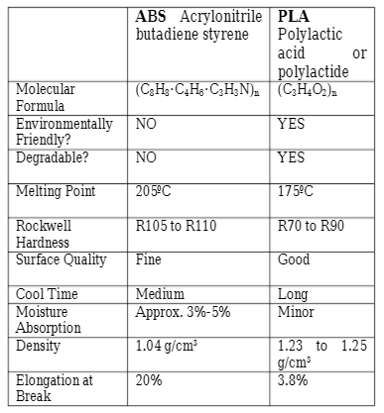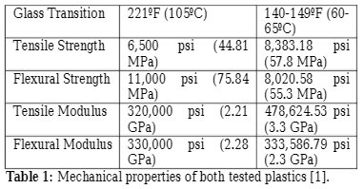

<https://www.researchgate.net/publication/308709141_Materials_Testing_of_3D_Printed_ABS_and_PLA_Samples_to_Guide_Mechanical_Design>

Using MTS Criterion or MTS Exceed as load frame options to perform tension test.

<https://www.mts.com/cs/groups/public/documents/library/mts_2013926.pdf>

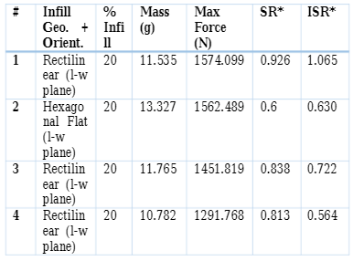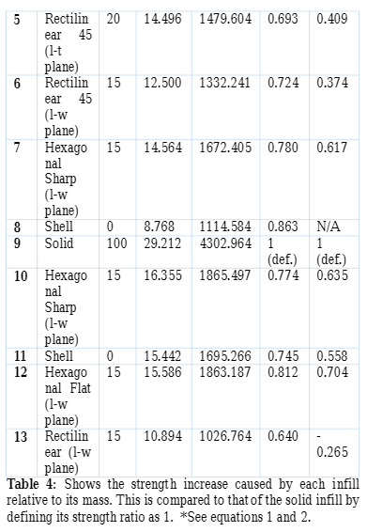

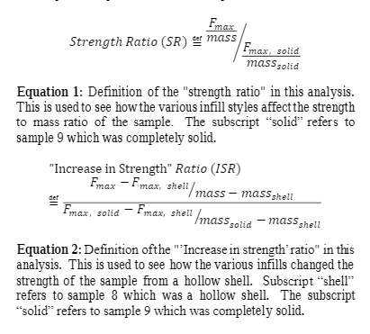

<https://www.researchgate.net/publication/308709141_Materials_Testing_of_3D_Printed_ABS_and_PLA_Samples_to_Guide_Mechanical_Design>

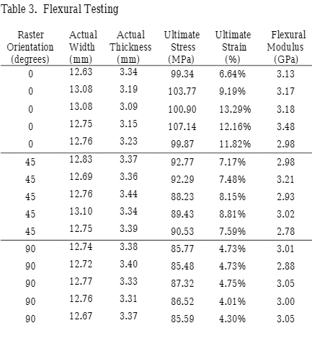

<https://www.researchgate.net/publication/272623242_Material_Property_Testing_of_3D-Printed_Specimen_in_PLA_on_an_Entry-Level_3D_Printer>

Analysis Methods

* Force vs displacement graphs
* Stress vs strain graphs
* Failure load
* Strength to weight ratio
* Compared between sample spec designs, repaired and normal versions

<https://openprairie.sdstate.edu/cgi/viewcontent.cgi?article=3508&context=etd>

<https://www.scielo.br/scielo.php?script=sci_arttext&pid=S1806-11172019000300401>

How to use a arduino to measure strain

# Experimentation Methodology

* Tensile or Flexural testing depending on sample spec and availability of machines
  + Without access to lab most likely using flexural
* 5 parts for each geometry we want to print on
  + 5 control specimens
    - Undamaged prints with the same infill as other parts
* Flexural Testing (3 Point Bend)
  + Needs to be tested to 5% strain
  + support span-to-depth ratio of 16:1
  + Two strain rates: 0.01 mm/mm/min (recommended) and 0.10 mm/mm/min
    - 0.10 mm/mm/min for if the material doesn’t break at 5% strain
  + A test sample bar rests on two supports and is loaded by means of a loading nose midway between the supports

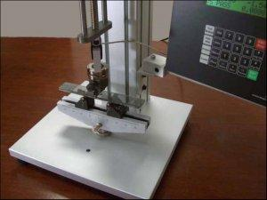

[**ASTM D790 Testing for Flexural Properties of Plastics and Insulating Materials**](https://www.testresources.net/applications/standards/astm/astm-d790-testing-for-flexural-properties-of-plastics-and-insulating-materials/)